EXPERIMENT-1:
Aim: To load a dataset, inspect it, handle missing and inconsistent values, and summarise it using descriptive statistics and charts.

Code:
import pandas as pd
import matplotlib.pyplot as plt

# Create sample dataset
data = {
"reg_no": [101, 102, 103, 104, 105, 106, 106],
"department": ["CSE", "IT", "CSE", "ECE", "IT", "CSE", "CSE"],
"gender": ["Male", "Female", "Male", "Female", "Male", "Female", "Female"],
"attendance": [90, 85, None, 95, 140, 80, 80],
"internal": [80, 75, 85, None, 70, 90, 90],
"final_exam": [85, 78, 90, 88, 65, 95, 95],
"study_hours": [5, 4, 6, 5, 3, 8, 8]
}

df = pd.DataFrame(data)

# Explore dataset
print("First Five Rows:")
print(df.head())

print("\nShape:")
print(df.shape)

print("\nDataset Information:")
df.info()

print("\nStatistical Summary:")
print(df.describe())

# Check missing values
print("\nMissing Values:")
print(df.isnull().sum())

# Fill missing numerical values
for col in df.select_dtypes(include="number").columns:
df[col] = df[col].fillna(df[col].median())

# Fill missing categorical values
for col in df.select_dtypes(include="object").columns:
df[col] = df[col].fillna(df[col].mode()[0])

# Remove duplicate rows
df = df.drop_duplicates()

# Correct impossible attendance
df.loc[df["attendance"] > 100, "attendance"] = 100

# Summary statistics
print("\nFinal Exam Statistics:")
print(df["final_exam"].describe())

print("\nDepartment-wise Average:")
print(df.groupby("department")["final_exam"].mean())

# Save cleaned dataset
df.to_csv("student_marks_clean.csv", index=False)

# Histogram
df["final_exam"].hist()
plt.title("Final Exam Marks")
plt.xlabel("Marks")
plt.ylabel("Frequency")
plt.show()

# Box plot
df.boxplot(column="final_exam", by="department")
plt.show()

# Scatter plot
plt.scatter(df["study_hours"], df["final_exam"])
plt.xlabel("Study Hours")
plt.ylabel("Final Exam Marks")
plt.title("Study Hours vs Final Exam")
plt.show()

# Correlation
print("\nCorrelation:")
print(df["study_hours"].corr(df["final_exam"]))

print("\nCleaned dataset saved successfully!")

Output:
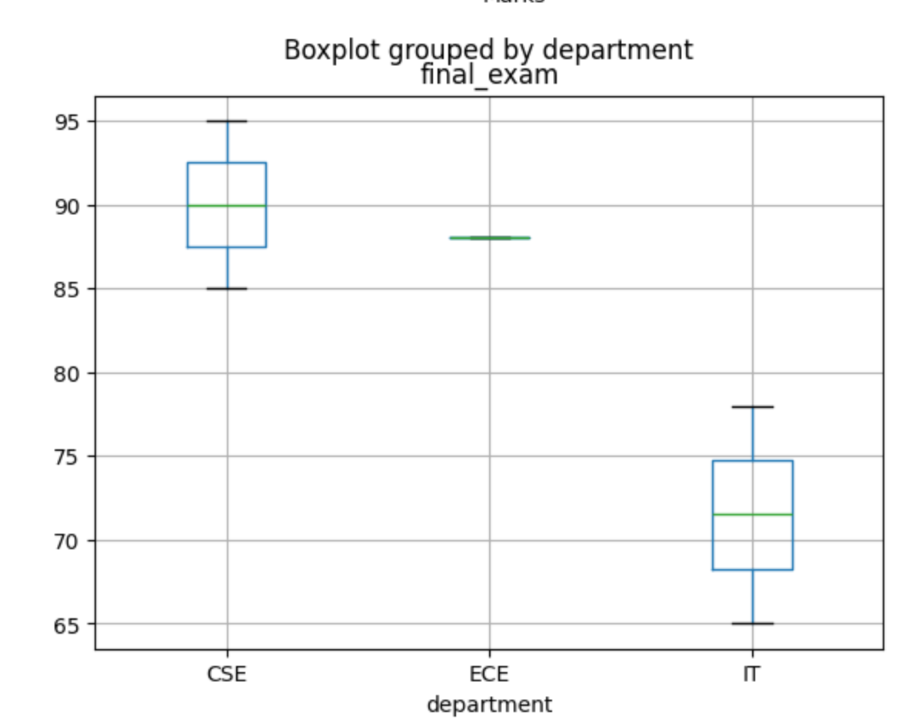

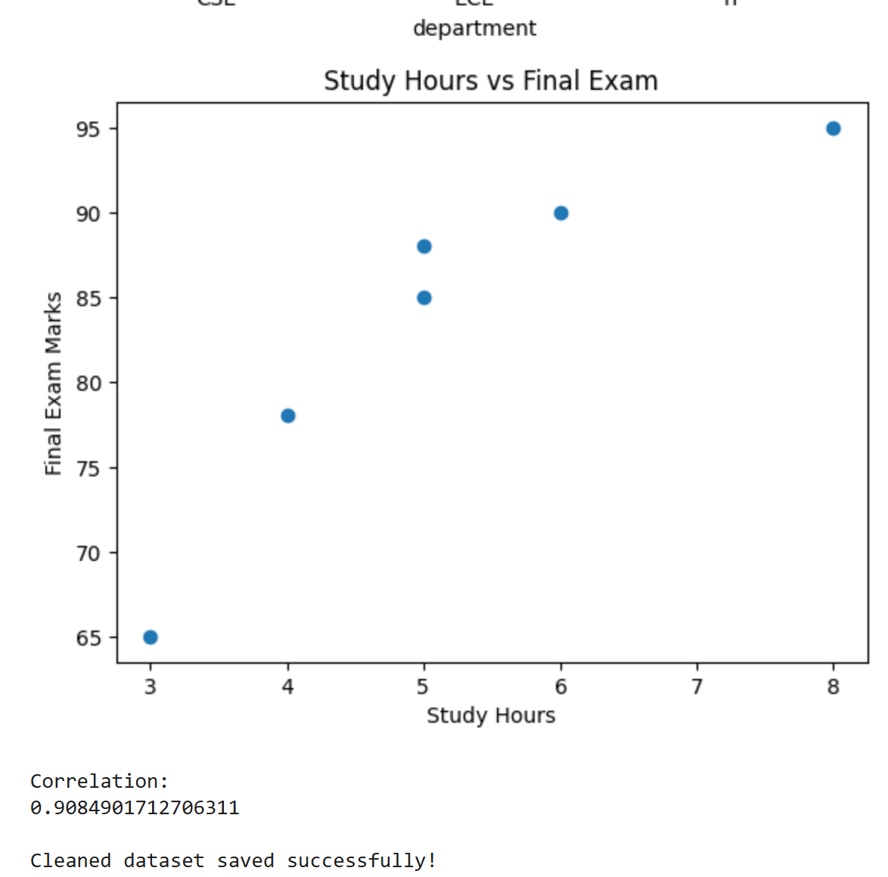

EXPERIMENT-2:
Experiment 2: Semantic Network and Inheritance Queries
Aim: To represent a domain as a semantic network and answer questions using inheritance and path searching.
Tools: Python, NetworkX, Matplotlib.

Code:
import networkx as nx
import matplotlib.pyplot as plt

# Create a directed graph
G = nx.DiGraph()

# Add nodes
nodes = ["Animal", "Bird", "Fish", "Canary", "Penguin", "Tweety"]
G.add_nodes_from(nodes)

# Add relationships
G.add_edge("Bird", "Animal", relation="is-a")
G.add_edge("Fish", "Animal", relation="is-a")
G.add_edge("Canary", "Bird", relation="is-a")
G.add_edge("Penguin", "Bird", relation="is-a")
G.add_edge("Tweety", "Canary", relation="instance-of")

# Add properties
properties = {
"Animal": {"can": "breathe"},
"Bird": {"can": "fly", "has-part": "wings"},
"Fish": {"can": "swim"},
"Canary": {"colour": "yellow"},
"Penguin": {"cannot": "fly"},
"Tweety": {"colour": "yellow"}
}

# Function to find inherited properties
def inherits(node, relation):
current = node

while current:
if relation in properties.get(current, {}):
return properties[current][relation], current

if relation == "can" and "cannot" in properties.get(current, {}):
return "No", current

parents = list(G.successors(current))

if not parents:
break

current = parents[0]

return "Not found", None

# Test queries
queries = [
("Tweety", "can"),
("Tweety", "has-part"),
("Penguin", "can"),
("Canary", "colour"),
("Animal", "can")
]

print("SEMANTIC NETWORK QUERIES")

for node, relation in queries:
value, source = inherits(node, relation)
print(node, "-", relation, ":", value,
"(inherited from", source, ")")

# Find path between two concepts
print("\nPath between Tweety and Animal:")

path = nx.shortest_path(G, "Tweety", "Animal")
print(" -> ".join(path))

# Draw semantic network
pos = nx.spring_layout(G, seed=42)

nx.draw(
G, pos,
with_labels=True,
node_color="lightblue",
node_size=2500,
font_size=10,
arrows=True
)

edge_labels = nx.get_edge_attributes(G, "relation")
nx.draw_networkx_edge_labels(G, pos, edge_labels=edge_labels)

plt.title("Animal Semantic Network")
plt.show()

Output:
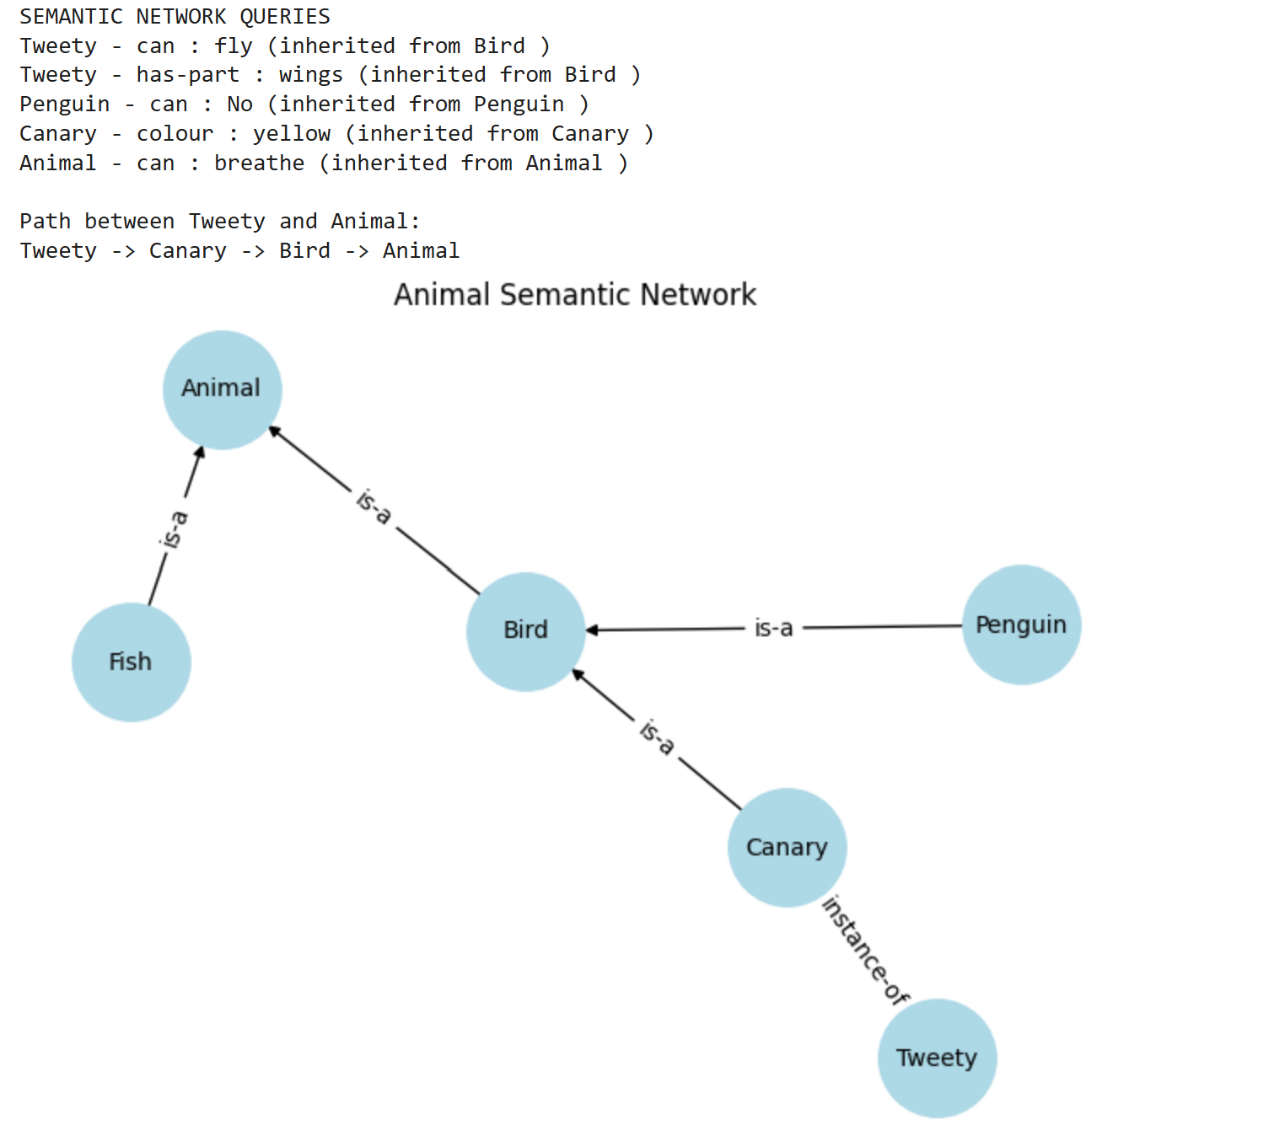

Experiment 3: Frames with Defaults, Inheritance and If-Needed Procedures
Aim: To implement frames in Python with slots, default values, inheritance and attached procedures.
Tools: Python (Classes and Dictionaries).
Code:
# Frame class
class Frame:
def __init__(self, name, parent=None):
self.name = name
self.parent = parent
self.slots = {}

# Add a slot
def add_slot(self, slot, value=None, default=None, if_needed=None):
self.slots[slot] = {
"value": value,
"default": default,
"if_needed": if_needed
}

# Get slot value using inheritance
def get(self, slot):
if slot in self.slots:
data = self.slots[slot]

if data["value"] is not None:
return data["value"], "Frame value"

if data["if_needed"] is not None:
return data["if_needed"](), "Procedure"

if data["default"] is not None:
return data["default"], "Default value"

if self.parent:
return self.parent.get(slot)

return "Not available", "Unknown"

# Set slot value
def set(self, slot, value):
if slot == "mileage" and value < 0:
print("Warning: Mileage cannot be negative!")
return

if slot not in self.slots:
self.add_slot(slot)

self.slots[slot]["value"] = value

# Create Vehicle frame
vehicle = Frame("Vehicle")
vehicle.add_slot("wheels", default=4)

# Create Car frame
car = Frame("Car", vehicle)
car.add_slot("fuel_type", default="Petrol")

# Create MyCar frame
mycar = Frame("MyCar", car)
mycar.add_slot("odometer", value=5000)
mycar.add_slot("fuel_used", value=100)

# If-needed procedure
def calculate_mileage():
return mycar.get("odometer")[0] / mycar.get("fuel_used")[0]

mycar.add_slot("mileage", if_needed=calculate_mileage)

# Display slot values
print("MY CAR FRAME DETAILS")

slots = ["wheels", "fuel_type", "odometer", "fuel_used", "mileage"]

for slot in slots:
value, source = mycar.get(slot)
print(slot, ":", value, "-", source)

# Demonstrate warning
print("\nTesting negative mileage:")
mycar.set("mileage", -10)
Output:

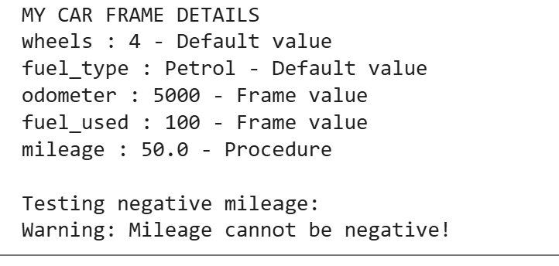

Experiment 4: Rule-Based System with Forward Chaining
Aim: To build a production system that applies IF-THEN rules to a set of facts using forward chaining.

Code:
# Rule-Based System using Forward Chaining

# Define rules as (rule name, conditions, conclusion)
rules = [
("R1", {"income_ok", "credit_good"}, "basic_eligible"),
("R2", {"basic_eligible", "stable_job"}, "approve"),
("R3", {"basic_eligible", "existing_debt"}, "review"),
("R4", {"low_income"}, "reject"),
("R5", {"poor_credit"}, "reject"),
("R6", {"high_debt"}, "reject"),
("R7", {"approve"}, "loan_offer"),
("R8", {"review", "documents_verified"}, "approve_after_review")
]

# Forward chaining function
def forward_chaining(initial_facts, strategy="first"):
facts = set(initial_facts)
cycle = 1

print("\nInitial Facts:", facts)

while True:
conflict_set = []

# Find matching rules
for name, conditions, conclusion in rules:
if conditions.issubset(facts) and conclusion not in facts:
conflict_set.append((name, conditions, conclusion))

if not conflict_set:
print("\nNo more rules can be applied.")
break

print("\nCycle", cycle)
print("Conflict Set:", [r[0] for r in conflict_set])

# Select a rule
if strategy == "specific":
selected_rule = max(
conflict_set,
key=lambda rule: len(rule[1])
)
else:
selected_rule = conflict_set[0]

name, conditions, conclusion = selected_rule

# Fire selected rule
facts.add(conclusion)

print("Fired Rule:", name)
print("New Fact:", conclusion)
print("Current Facts:", facts)

cycle += 1

print("\nFinal Conclusions:", facts)

# Test Case 1
print("\n========== TEST CASE 1 ==========")
facts1 = {"income_ok", "credit_good", "stable_job"}
forward_chaining(facts1, "first")

# Test Case 2
print("\n========== TEST CASE 2 ==========")
facts2 = {
"income_ok", "credit_good",
"stable_job", "existing_debt",
"documents_verified"
}
forward_chaining(facts2, "specific")

# Test Case 3
print("\n========== TEST CASE 3 ==========")
facts3 = {"student", "no_income_information"}
forward_chaining(facts3, "first")
Output:
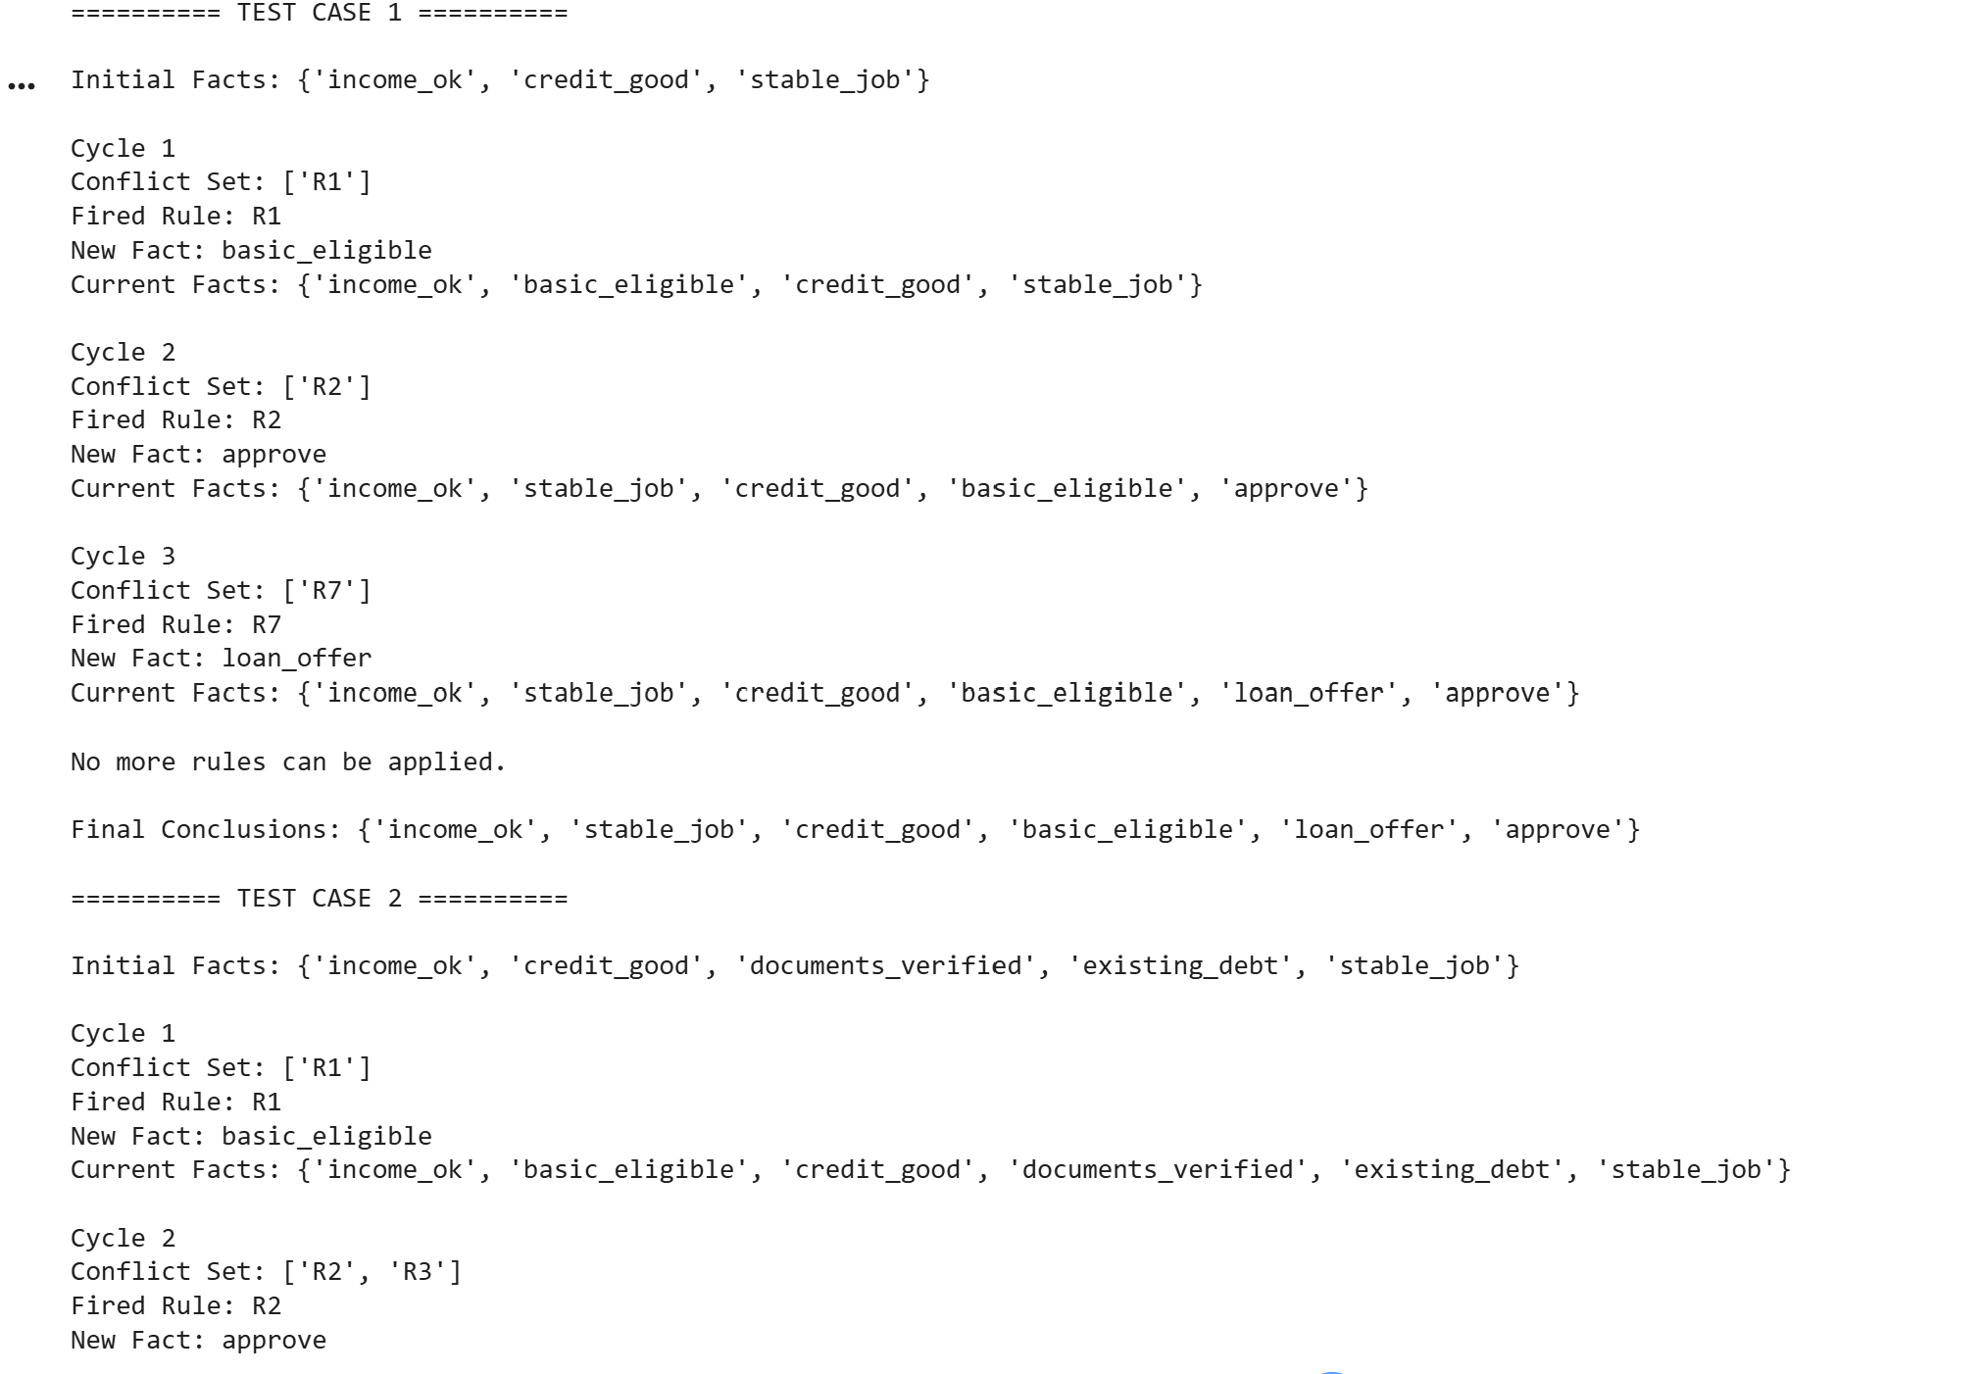
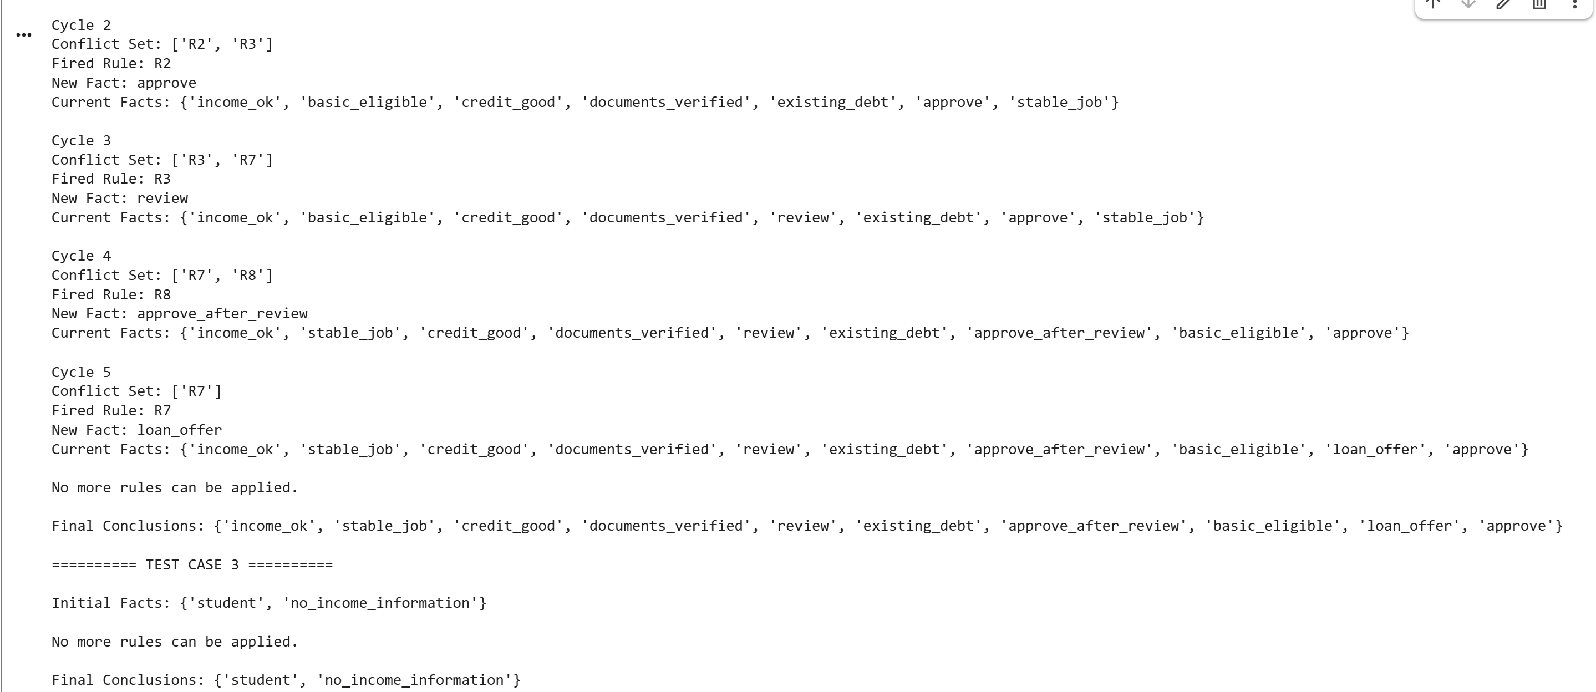

Experiment 5: Backward Chaining with a Why/How Explanation Facility
Aim: To implement goal-driven reasoning that asks the user for missing facts and explains why it asks questions and how it reaches a conclusion

Code:
# Backward Chaining with Why/How Explanation
# Plant Disease Diagnosis

# Define 12 rules
rules = [
("R1", ["yellow_leaves", "brown_spots"], "fungal_disease"),
("R2", ["white_powder", "leaf_curl"], "fungal_disease"),
("R3", ["moist_soil", "root_rot"], "fungal_disease"),
("R4", ["water_soaked_spots", "yellow_halo"], "bacterial_disease"),
("R5", ["stem_wilting", "dark_stem"], "bacterial_disease"),
("R6", ["leaf_blight", "yellow_halo"], "bacterial_disease"),
("R7", ["holes_in_leaves", "visible_insects"], "pest_attack"),
("R8", ["sticky_leaves", "visible_insects"], "pest_attack"),
("R9", ["curled_leaves", "small_insects"], "pest_attack"),
("R10", ["healthy_leaves", "normal_growth"], "healthy_plant"),
("R11", ["green_leaves", "normal_growth"], "healthy_plant"),
("R12", ["no_spots", "no_insects"], "healthy_plant")
]

# Basic observations that can be asked
askable = {
"yellow_leaves", "brown_spots",
"white_powder", "leaf_curl",
"moist_soil", "root_rot",
"water_soaked_spots", "yellow_halo",
"stem_wilting", "dark_stem",
"leaf_blight", "holes_in_leaves",
"visible_insects", "sticky_leaves",
"curled_leaves", "small_insects",
"healthy_leaves", "normal_growth",
"green_leaves", "no_spots", "no_insects"
}

facts = {}
proof_trace = []
asked_questions = []
current_goal = None

# Backward chaining function
def prove(goal):

global current_goal

# Check known facts
if goal in facts:
return facts[goal]

# Find rules that conclude this goal
matching_rules = [
rule for rule in rules if rule[2] == goal
]

# Try each matching rule
for rule_id, conditions, conclusion in matching_rules:

print("\nTrying Rule:", rule_id)

current_goal = goal
success = True

for condition in conditions:

current_goal = goal

if not prove(condition):
success = False
break

if success:
proof_trace.append(rule_id)
return True

# Ask user if it is a basic observation
if goal in askable:

while True:
answer = input(
"\nIs " + goal.replace("_", " ") +
" present? (yes/no/why): "
).lower().strip()

if answer == "why":
print("WHY: This question is asked to prove:",
current_goal)
print("Related rules:")

for rule in matching_rules:
print(rule[0], "IF", rule[1],
"THEN", rule[2])

continue

if answer in ["yes", "y"]:
facts[goal] = True
asked_questions.append(goal)
return True

elif answer in ["no", "n"]:
facts[goal] = False
asked_questions.append(goal)
return False

else:
print("Please enter yes, no or why.")

return False

# Consultation function
def consultation(number):

global facts, proof_trace, asked_questions

facts = {}
proof_trace = []
asked_questions = []

print("\n========== CONSULTATION", number, "==========")

goals = [
"fungal_disease",
"bacterial_disease",
"pest_attack",
"healthy_plant"
]

diagnosis = None

for goal in goals:

if prove(goal):
diagnosis = goal
break

print("\nHOW: Explanation of the result")

if diagnosis:
print("Diagnosis:", diagnosis.replace("_", " ").title())
print("Rules used:", proof_trace)
else:
print("No diagnosis could be established.")
print("The available facts were insufficient.")

print("Questions asked:", len(asked_questions))
print("Facts collected:", facts)

# Run four consultations
for i in range(1, 5):
consultation(i)
Ouptut:
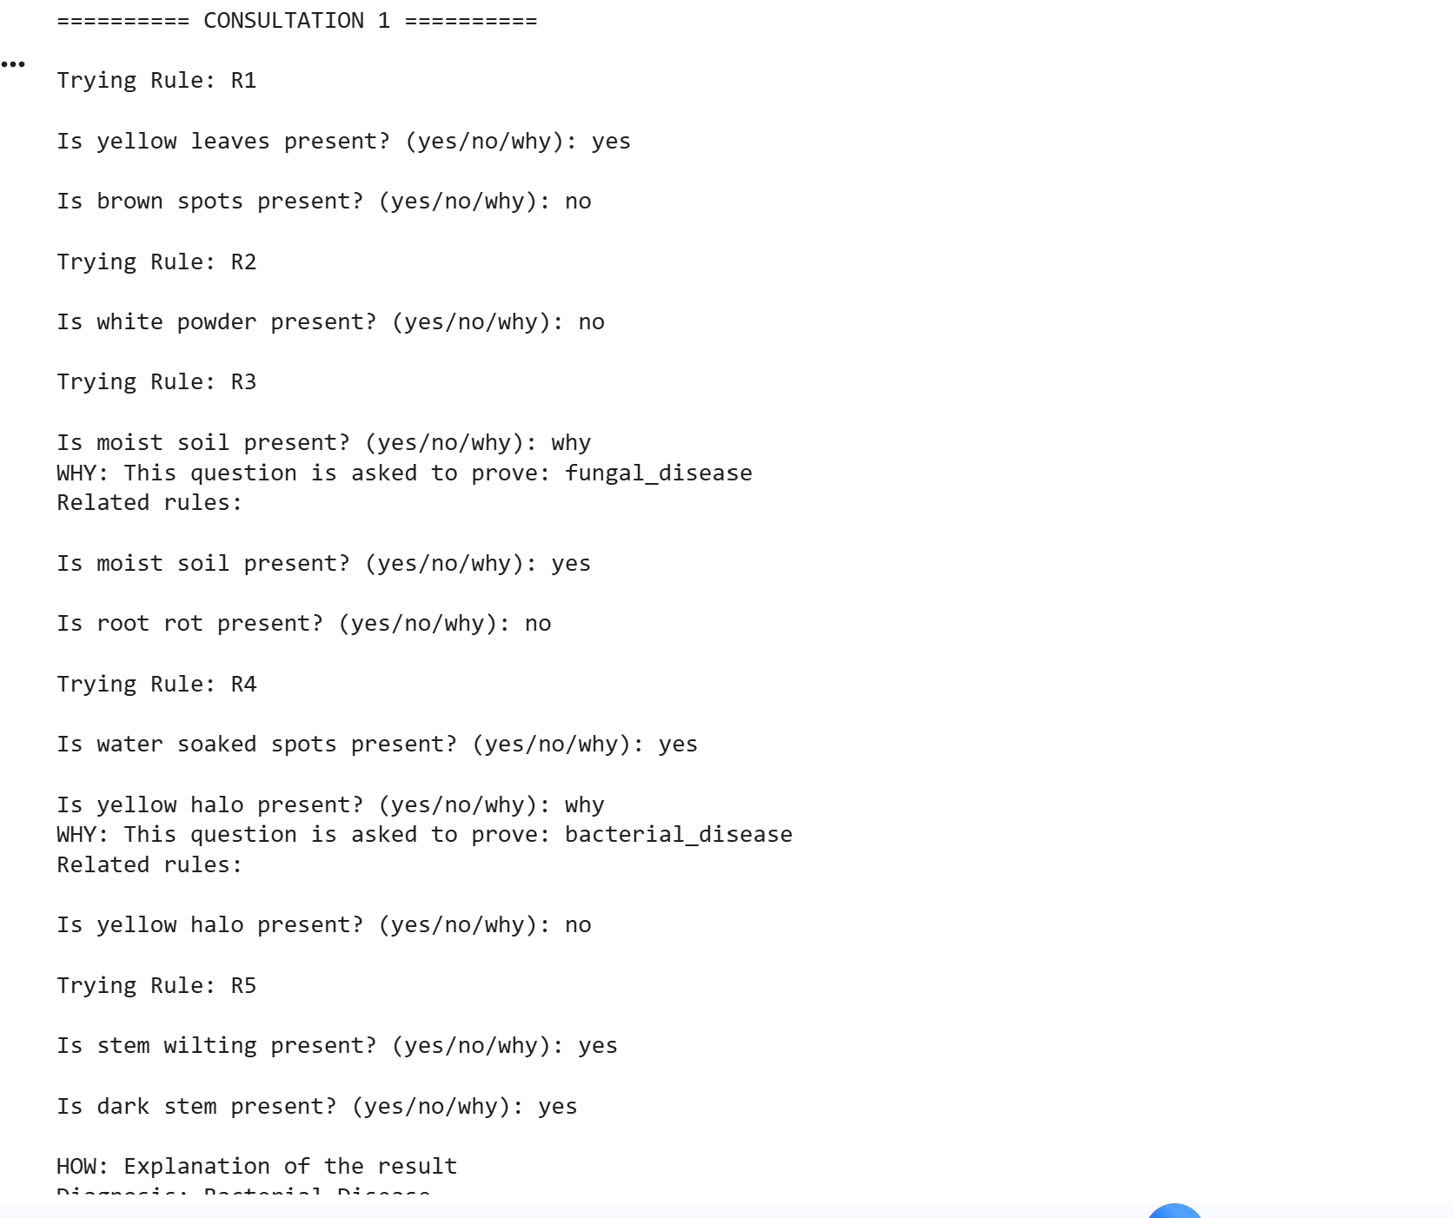
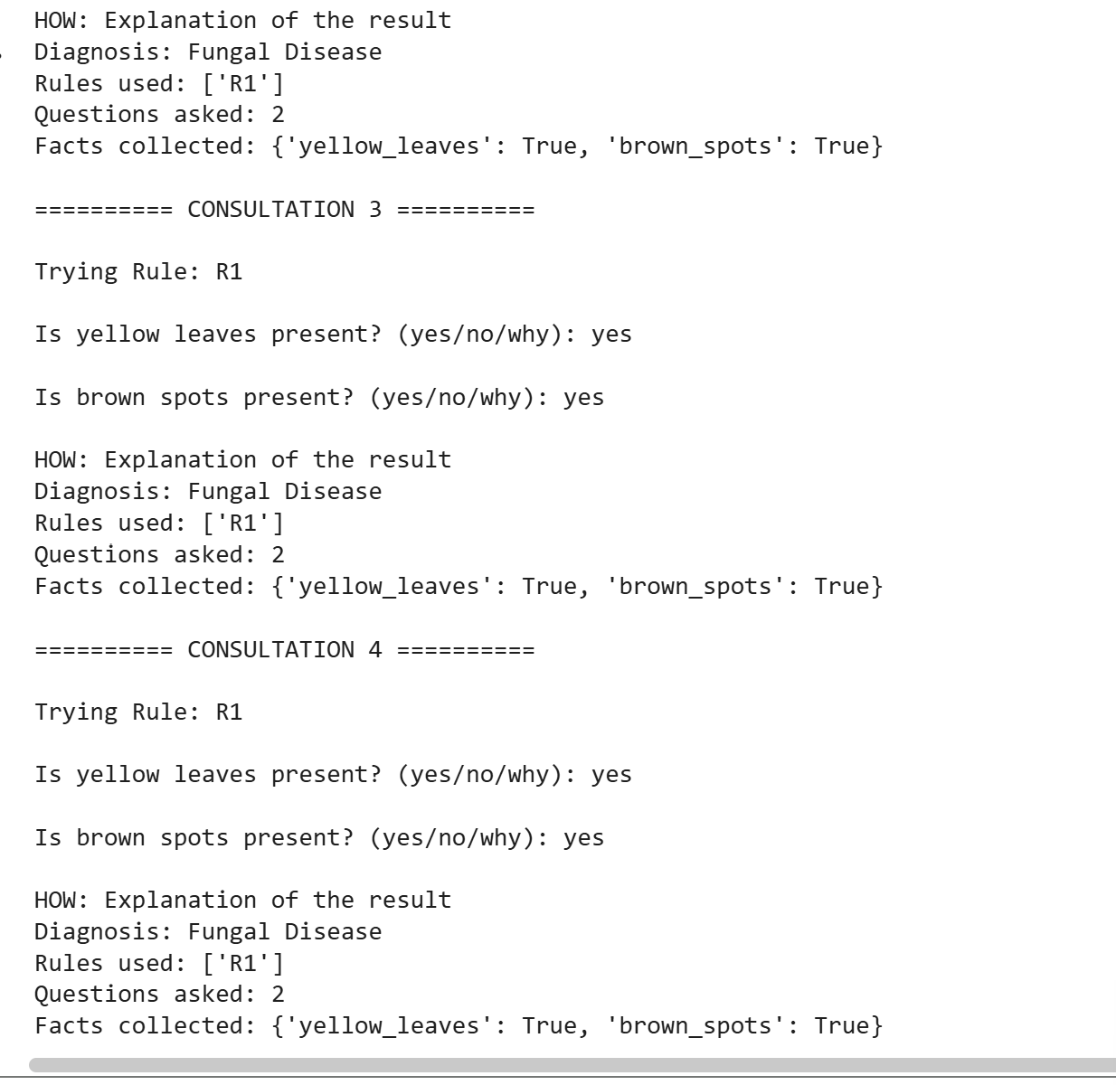

Experiment 6: Building and Reasoning over an Ontology
Aim: To design a small ontology, create instances, and use a reasoner to check consistency and infer new facts.
Code:

from owlready2 import *

# Create ontology
onto = get_ontology("http://example.org/university.owl")

with onto:

# Create classes
class Person(Thing):
pass

class Student(Person):
pass

class Faculty(Person):
pass

class Course(Thing):
pass

class Department(Thing):
pass

class UndergraduateStudent(Student):
pass

class PostgraduateStudent(Student):
pass

class OnlineCourse(Course):
pass

# Student and Faculty are disjoint
AllDisjoint([Student, Faculty])

# Object properties
class enrolledIn(ObjectProperty):
domain = [Student]
range = [Course]

class teaches(ObjectProperty):
domain = [Faculty]
range = [Course]

class belongsTo(ObjectProperty):
domain = [Person]
range = [Department]

class isTaughtBy(ObjectProperty):
inverse_property = teaches

# Data properties
class hasName(DataProperty):
domain = [Person]
range = [str]

class hasCredits(DataProperty):
domain = [Course]
range = [int]

# Every course must have at least one teacher
Course.is_a.append(isTaughtBy.min(1, Faculty))

# Create individuals
cs = Department("ComputerScience")
ai = Department("ArtificialIntelligence")

c1 = Course("PythonCourse")
c2 = Course("AICourse")

f1 = Faculty("Professor_Ravi")
f2 = Faculty("Professor_Anu")

s1 = Person("Asha")
s2 = UndergraduateStudent("Arun")
s3 = PostgraduateStudent("Priya")
s4 = Student("Kumar")

# Assign properties
s1.hasName = ["Asha"]
s2.hasName = ["Arun"]
s3.hasName = ["Priya"]
s4.hasName = ["Kumar"]

c1.hasCredits = [4]
c2.hasCredits = [3]

s1.enrolledIn.append(c1)
s2.enrolledIn.append(c1)
s3.enrolledIn.append(c2)
s4.enrolledIn.append(c2)

f1.teaches.append(c1)
f2.teaches.append(c2)

s1.belongsTo.append(ai)
s2.belongsTo.append(cs)
s3.belongsTo.append(ai)
s4.belongsTo.append(cs)

# Run reasoner
print("Running HermiT Reasoner...")

with onto:
sync_reasoner(infer_property_values=True)

print("\nOntology is consistent.")

# Display inferred student membership
print("\nInferred Class Membership:")

for person in onto.Person.instances():
if Student in person.INDIRECT_is_a:
print(person.name, "is inferred as Student")

# Competency questions
print("\nCOMPETENCY QUESTIONS")

print("\n1. Which courses does Asha attend?")
for course in s1.enrolledIn:
print(course.name)

print("\n2. Which courses are taught by Professor Ravi?")
for course in f1.teaches:
print(course.name)

print("\n3. Which department does Arun belong to?")
for department in s2.belongsTo:
print(department.name)

print("\n4. How many credits does Python Course have?")
print(c1.hasCredits)

print("\n5. Who are the students?")
for person in onto.Person.instances():
if Student in person.INDIRECT_is_a:
print(person.name)

# Save ontology
onto.save(file="university.owl", format="rdfxml")

print("\nOntology saved successfully!")

# Create deliberate inconsistency
print("\nTesting Inconsistency:")

conflict = Person("ConflictPerson")
conflict.is_a.append(Student)
conflict.is_a.append(Faculty)

try:
with onto:
sync_reasoner()
print("No inconsistency detected.")
except OwlReadyInconsistentOntologyError:
print("Inconsistency detected!")
print("One person cannot be both Student and Faculty.")
Output:
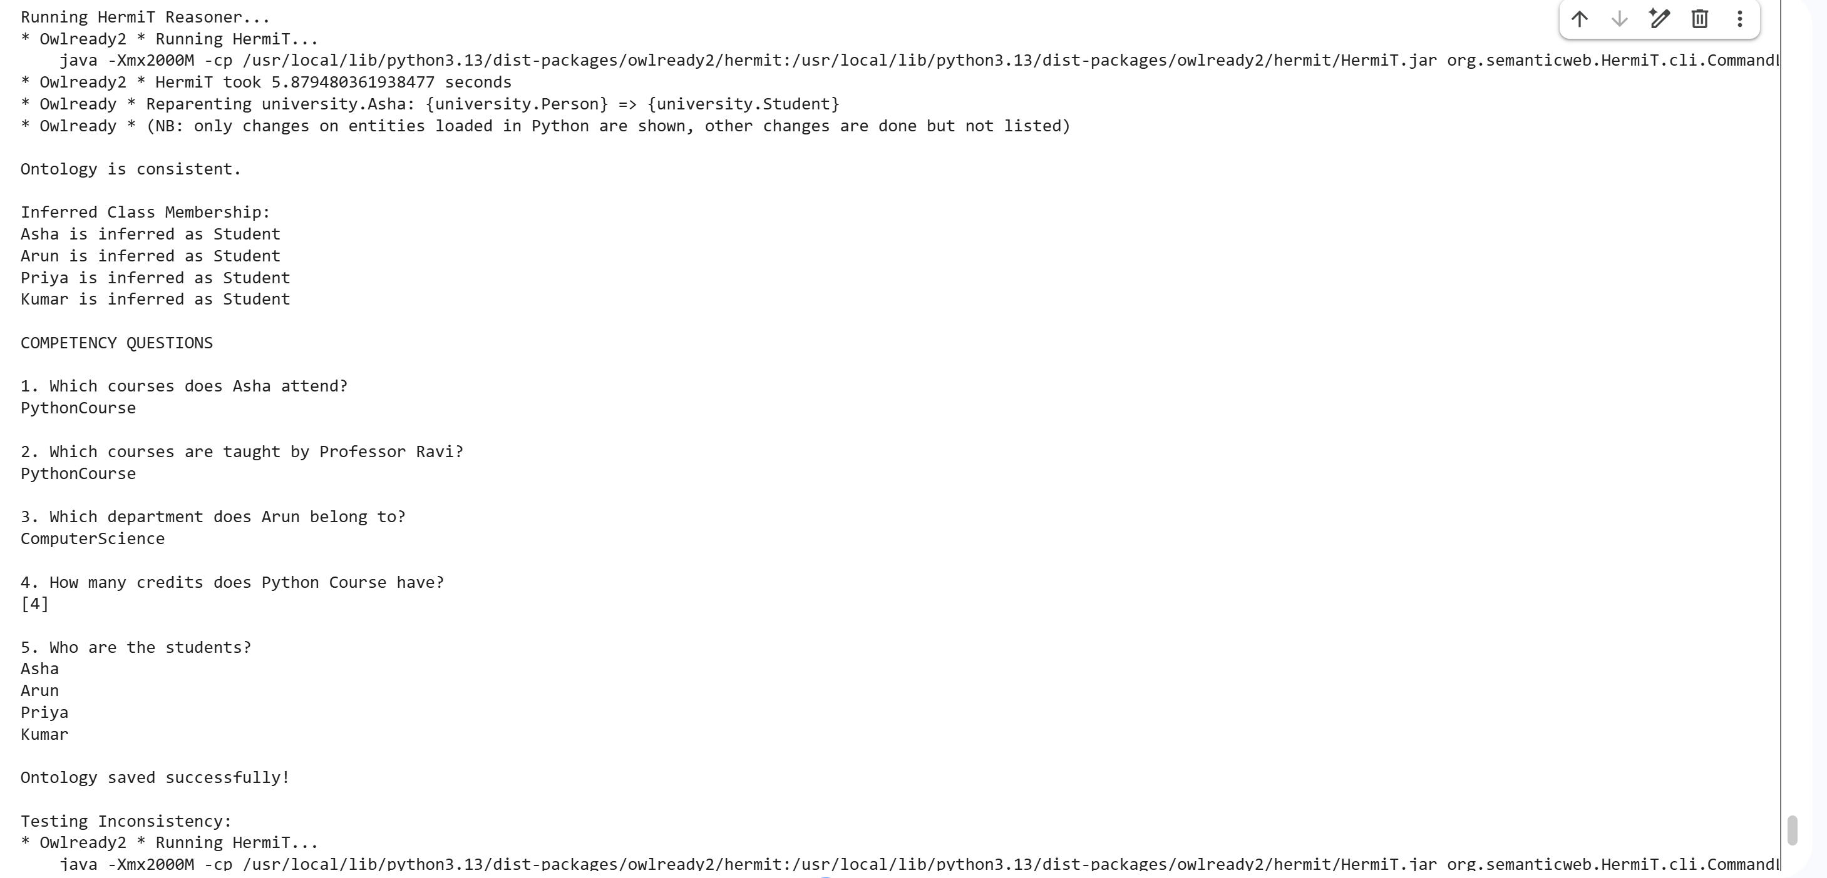

Experiment 7: Building and Querying a Knowledge Graph
Aim: To construct a knowledge graph from tabular and text data, resolve duplicate entities, and query the graph.
Code:
import pandas as pd
import networkx as nx
import matplotlib.pyplot as plt
import re
from difflib import SequenceMatcher
from rdflib import Graph, Namespace, Literal, RDF, RDFS, URIRef
from rdflib.namespace import XSD

# --------------------------------------------------
# 1. CREATE SAMPLE CSV DATA
# --------------------------------------------------

people_data = {
"person_id": ["P1", "P2", "P3", "P4", "P5", "P6"],
"name": ["Asha", "Ravi", "Meena", "Arun Kumar",
"A. Kumar", "Priya"],
"department": ["CSE", "IT", "CSE", "AI", "AI", "IT"],
"city": ["Chennai", "Bangalore", "Chennai",
"Chennai", "Chennai", "Hyderabad"]
}

works_data = {
"person_id": ["P1", "P2", "P3", "P4", "P5", "P6"],
"project": ["Project Alpha", "Project Beta",
"Project Gamma", "Project Alpha",
"Project Delta", "Project Beta"],
"role": ["Developer", "Tester", "Analyst",
"Designer", "Researcher", "Developer"]
}

pd.DataFrame(people_data).to_csv("people.csv", index=False)
pd.DataFrame(works_data).to_csv("works.csv", index=False)

people = pd.read_csv("people.csv")
works = pd.read_csv("works.csv")

print("People Data:")
print(people)

print("\nWorks Data:")
print(works)

# --------------------------------------------------
# 2. DEFINE KNOWLEDGE GRAPH AND SCHEMA
# --------------------------------------------------

g = Graph()
EX = Namespace("http://example.org/knowledge/")

g.bind("ex", EX)

# Define classes
classes = ["Person", "Project", "Department", "City"]

for cls in classes:
g.add((EX[cls], RDF.type, RDFS.Class))

# Define properties
properties = ["worksOn", "memberOf", "livesIn", "hasRole"]

for prop in properties:
g.add((EX[prop], RDF.type, RDF.Property))

# Store people information
person_uri = {}

# Convert people.csv rows into RDF triples
for _, row in people.iterrows():

p = EX["Person_" + row["person_id"]]
person_uri[row["person_id"]] = p

g.add((p, RDF.type, EX.Person))
g.add((p, EX.name, Literal(row["name"])))

dept = EX["Department_" + row["department"]]
city = EX["City_" + row["city"]]

g.add((dept, RDF.type, EX.Department))
g.add((city, RDF.type, EX.City))

g.add((p, EX.memberOf, dept))
g.add((p, EX.livesIn, city))

# --------------------------------------------------
# 3. CONVERT WORKS.CSV INTO RDF TRIPLES
# --------------------------------------------------

for _, row in works.iterrows():

p = person_uri[row["person_id"]]
project = EX["Project_" + row["project"].replace(" ", "_")]

g.add((project, RDF.type, EX.Project))
g.add((p, EX.worksOn, project))
g.add((p, EX.hasRole, Literal(row["role"])))

# --------------------------------------------------
# 4. EXTRACT TRIPLES FROM 10 TEXT SENTENCES
# --------------------------------------------------

sentences = [
"Asha works on Project Alpha at Anna University",
"Ravi works on Project Beta at Anna University",
"Meena works on Project Gamma at Anna University",
"Arun Kumar works on Project Alpha at Anna University",
"A. Kumar works on Project Delta at Anna University",
"Priya works on Project Beta at Anna University",
"Asha works on Project Gamma at Anna University",
"Ravi works on Project Alpha at Anna University",
"Meena works on Project Beta at Anna University",
"Priya works on Project Delta at Anna University"
]

# Map names to their original person resources
name_to_uri = {}

for _, row in people.iterrows():
name_to_uri[row["name"]] = person_uri[row["person_id"]]

for sentence in sentences:

match = re.match(
r"(.+?) works on (.+?) at (.+)",
sentence
)

if match:
person_name = match.group(1).strip()
project_name = match.group(2).strip()

if person_name in name_to_uri:

p = name_to_uri[person_name]

project = EX[
"Project_" + project_name.replace(" ", "_")
]

g.add((project, RDF.type, EX.Project))
g.add((p, EX.worksOn, project))

print("\nText sentences converted into RDF triples.")

# --------------------------------------------------
# 5. ENTITY RESOLUTION - FIND DUPLICATE PERSON
# --------------------------------------------------

def similar_person(name1, name2):

# Example: A. Kumar and Arun Kumar
n1 = name1.lower().replace(".", "").split()
n2 = name2.lower().replace(".", "").split()

same_initial_surname = (
len(n1) >= 2 and len(n2) >= 2
and n1[-1] == n2[-1]
and n1[0][0] == n2[0][0]
)

similarity = SequenceMatcher(
None, name1.lower(), name2.lower()
).ratio()

return same_initial_surname or similarity >= 0.75

duplicate_found = False

for i in range(len(people)):

for j in range(i + 1, len(people)):

name1 = people.iloc[i]["name"]
name2 = people.iloc[j]["name"]

dept1 = people.iloc[i]["department"]
dept2 = people.iloc[j]["department"]

if dept1 == dept2 and similar_person(name1, name2):

id1 = people.iloc[i]["person_id"]
id2 = people.iloc[j]["person_id"]

# Use Arun Kumar as the canonical person
if name1 == "A. Kumar":
duplicate_id, main_id = id1, id2
else:
duplicate_id, main_id = id2, id1

duplicate_uri = person_uri[duplicate_id]
main_uri = person_uri[main_id]

# Replace duplicate URI with canonical URI
for s, p, o in list(g.triples((duplicate_uri, None, None))):
g.add((main_uri, p, o))

for s, p, o in list(g.triples((None, None, duplicate_uri))):
g.add((s, p, main_uri))

g.remove((duplicate_uri, None, None))
g.remove((None, None, duplicate_uri))

person_uri[duplicate_id] = main_uri

print("\nDuplicate detected:")
print(name1, "and", name2)
print("Same department:", dept1)
print("Decision: Merged as Arun Kumar")

duplicate_found = True

if not duplicate_found:
print("No duplicate person found.")

# --------------------------------------------------
# 6. SAVE KNOWLEDGE GRAPH
# --------------------------------------------------

g.serialize(
destination="knowledge_graph.ttl",
format="turtle"
)

print("\nKnowledge graph saved as knowledge_graph.ttl")
print("Total RDF triples:", len(g))

# --------------------------------------------------
# 7. EXECUTE FIVE SPARQL QUERIES
# --------------------------------------------------

# Query 1: Who works on Project Alpha?
q1 = """
PREFIX ex: <http://example.org/knowledge/>

SELECT DISTINCT ?person
WHERE {
?person ex:worksOn ex:Project_Project_Alpha .
?person ex:name ?name .
}
"""

# Query 2: Who belongs to the same department as Asha?
q2 = """
PREFIX ex: <http://example.org/knowledge/>

SELECT DISTINCT ?personName
WHERE {
?asha ex:name "Asha" ;
ex:memberOf ?department .

?person ex:memberOf ?department ;
ex:name ?personName .

FILTER (?person != ?asha)
}
"""

# Query 3: Which projects involve people in Chennai?
q3 = """
PREFIX ex: <http://example.org/knowledge/>

SELECT DISTINCT ?project
WHERE {
?person ex:livesIn ex:City_Chennai ;
ex:worksOn ?project .
}
"""

# Query 4: Who belongs to the AI department?
q4 = """
PREFIX ex: <http://example.org/knowledge/>

SELECT DISTINCT ?name
WHERE {
?person ex:memberOf ex:Department_AI ;
ex:name ?name .
}
"""

# Query 5: Which projects does Priya work on?
q5 = """
PREFIX ex: <http://example.org/knowledge/>

SELECT DISTINCT ?project
WHERE {
?person ex:name "Priya" ;
ex:worksOn ?project .
}
"""

queries = [
("People working on Project Alpha", q1),
("People in Asha's department", q2),
("Projects involving people in Chennai", q3),
("People in AI department", q4),
("Projects worked on by Priya", q5)
]

for title, query in queries:

print("\n", title)

results = g.query(query)

for row in results:
print(row)

# --------------------------------------------------
# 8. CONVERT RDF GRAPH INTO NETWORKX GRAPH
# --------------------------------------------------

G = nx.Graph()

for subject, predicate, obj in g:

G.add_edge(
str(subject).split("/")[-1],
str(obj).split("/")[-1],
relation=str(predicate).split("/")[-1]
)

# Calculate degree of each node
degrees = dict(G.degree())

print("\nNode Degrees:")

for node, degree in degrees.items():
print(node, ":", degree)

# Find most connected entity
most_connected = max(degrees, key=degrees.get)

print("\nMost Connected Entity:", most_connected)
print("Degree:", degrees[most_connected])

# --------------------------------------------------
# 9. DRAW KNOWLEDGE GRAPH
# --------------------------------------------------

plt.figure(figsize=(15, 10))

pos = nx.spring_layout(G, seed=42)

nx.draw(
G,
pos,
with_labels=True,
node_size=1800,
font_size=7,
arrows=False
)

edge_labels = nx.get_edge_attributes(G, "relation")

nx.draw_networkx_edge_labels(
G,
pos,
edge_labels=edge_labels,
font_size=6
)

plt.title("Knowledge Graph")
plt.axis("off")
plt.show()
Output:
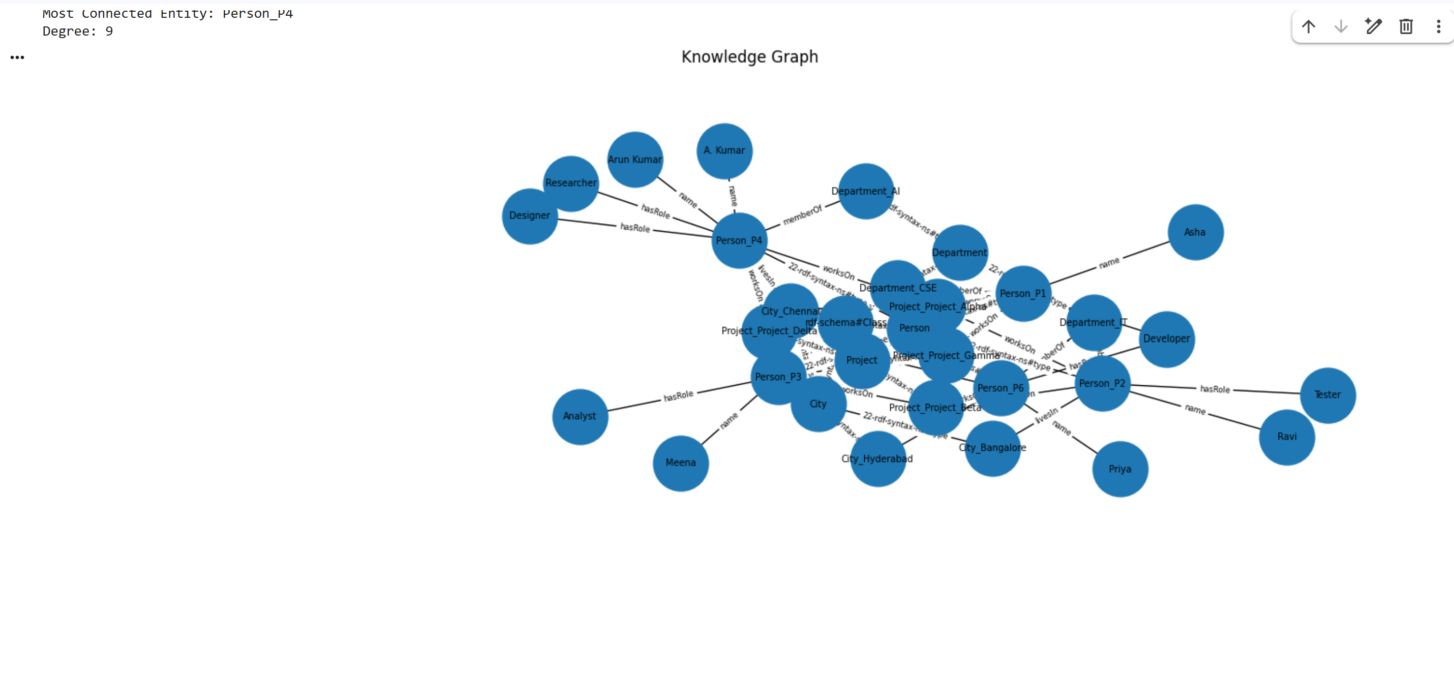
Experiment 8: Hypothesis Testing, ANOVA and Chi-Square with Evidence
Aim: To test claims about data using t-tests, ANOVA and the chi-square test, and to state conclusions supported by test statistics and p-values.

Code:

import pandas as pd
import numpy as np
import matplotlib.pyplot as plt
from scipy import stats

# ------------------------------------------------
# 1. CREATE SAMPLE DATASET
# ------------------------------------------------

np.random.seed(42)

n = 20

method_A_before = np.random.normal(50, 5, n)
method_B_before = np.random.normal(50, 5, n)
method_C_before = np.random.normal(50, 5, n)

method_A_after = method_A_before + np.random.normal(8, 3, n)
method_B_after = method_B_before + np.random.normal(15, 3, n)
method_C_after = method_C_before + np.random.normal(20, 3, n)

data = []

methods = [
("A", method_A_before, method_A_after),
("B", method_B_before, method_B_after),
("C", method_C_before, method_C_after)
]

student_id = 1

for method, before, after in methods:
for i in range(n):

score = round(after[i], 2)

gender = "Male" if i % 2 == 0 else "Female"
result = "Pass" if score >= 60 else "Fail"

data.append([
student_id, method,
round(before[i], 2),
score, gender, result
])

student_id += 1

df = pd.DataFrame(data, columns=[
"student", "method", "score_before",
"score_after", "gender", "result"
])

df.to_csv("exam_scores.csv", index=False)

print("Dataset:")
print(df.head())

print("\nDataset Shape:", df.shape)

# ------------------------------------------------
# 2. SET SIGNIFICANCE LEVEL
# ------------------------------------------------

alpha = 0.05

results = []

def add_result(test_name, hypothesis, statistic, p_value, conclusion):

decision = (
"Reject H0"
if p_value < alpha
else "Fail to reject H0"
)

results.append([
test_name, hypothesis,
round(statistic, 4),
round(p_value, 4),
decision, conclusion
])

# ------------------------------------------------
# 3. ONE-SAMPLE T-TEST
# ------------------------------------------------

# H0: Mean score_after = 60
# H1: Mean score_after is different from 60

t_stat, p_value = stats.ttest_1samp(
df["score_after"], popmean=60
)

add_result(
"One-sample t-test",
"H0: Mean = 60; H1: Mean != 60",
t_stat, p_value,
"Mean score is significantly different from 60"
if p_value < alpha
else "No significant difference from 60"
)

# ------------------------------------------------
# 4. INDEPENDENT-SAMPLES T-TEST
# ------------------------------------------------

# H0: Mean scores of A and B are equal
# H1: Mean scores of A and B are different

A = df[df["method"] == "A"]["score_after"]
B = df[df["method"] == "B"]["score_after"]

t_stat, p_value = stats.ttest_ind(
A, B, equal_var=False
)

add_result(
"Independent t-test",
"H0: Mean A = Mean B; H1: Mean A != Mean B",
t_stat, p_value,
"Methods A and B differ significantly"
if p_value < alpha
else "No significant difference between A and B"
)

# ------------------------------------------------
# 5. PAIRED T-TEST
# ------------------------------------------------

# H0: Before and after mean scores are equal
# H1: Before and after mean scores are different

t_stat, p_value = stats.ttest_rel(
df["score_before"],
df["score_after"]
)

add_result(
"Paired t-test",
"H0: Before = After; H1: Before != After",
t_stat, p_value,
"Scores changed significantly after teaching"
if p_value < alpha
else "No significant change in scores"
)

# ------------------------------------------------
# 6. ONE-WAY ANOVA
# ------------------------------------------------

# H0: All three method means are equal
# H1: At least one method mean is different

A = df[df["method"] == "A"]["score_after"]
B = df[df["method"] == "B"]["score_after"]
C = df[df["method"] == "C"]["score_after"]

f_stat, p_value = stats.f_oneway(A, B, C)

add_result(
"One-way ANOVA",
"H0: Means A = B = C; H1: At least one differs",
f_stat, p_value,
"At least one teaching method differs significantly"
if p_value < alpha
else "No significant difference among methods"
)

print("\nMean Scores by Method:")
print(df.groupby("method")["score_after"].mean())

# ------------------------------------------------
# 7. CHI-SQUARE TEST
# ------------------------------------------------

# H0: Gender and result are independent
# H1: Gender and result are associated

contingency_table = pd.crosstab(
df["gender"], df["result"]
)

chi_stat, p_value, dof, expected = stats.chi2_contingency(
contingency_table
)

add_result(
"Chi-square test",
"H0: Gender and result are independent",
chi_stat, p_value,
"Gender and result are significantly associated"
if p_value < alpha
else "No significant association between gender and result"
)

print("\nContingency Table:")
print(contingency_table)

# ------------------------------------------------
# 8. DISPLAY RESULTS TABLE
# ------------------------------------------------

result_table = pd.DataFrame(results, columns=[
"Test",
"Hypothesis",
"Statistic",
"P-value",
"Decision",
"Conclusion"
])

print("\nHYPOTHESIS TESTING RESULTS")
print(result_table.to_string(index=False))

# ------------------------------------------------
# 9. CALCULATE 95% CONFIDENCE INTERVAL
# ------------------------------------------------

scores = df["score_after"]

mean_score = scores.mean()
standard_error = stats.sem(scores)

confidence_interval = stats.t.interval(
0.95,
df=len(scores) - 1,
loc=mean_score,
scale=standard_error
)

print("\n95% CONFIDENCE INTERVAL")
print("Mean Score:", round(mean_score, 2))
print("Lower Limit:", round(confidence_interval[0], 2))
print("Upper Limit:", round(confidence_interval[1], 2))

# ------------------------------------------------
# 10. DRAW BOXPLOT
# ------------------------------------------------

plt.figure(figsize=(8, 5))

df.boxplot(
column="score_after",
by="method"
)

plt.title("Exam Scores by Teaching Method")
plt.suptitle("")
plt.xlabel("Teaching Method")
plt.ylabel("Score After Teaching")
plt.grid(True)

plt.show()
Output:
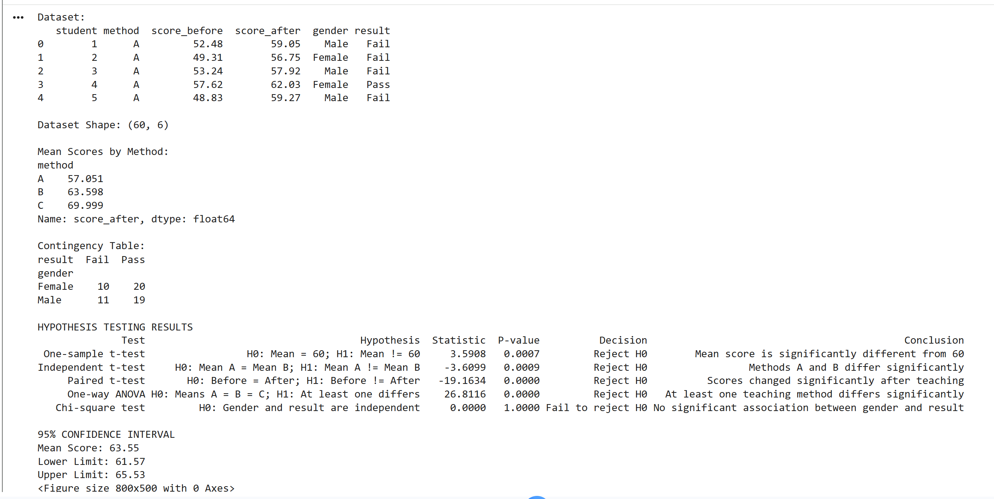

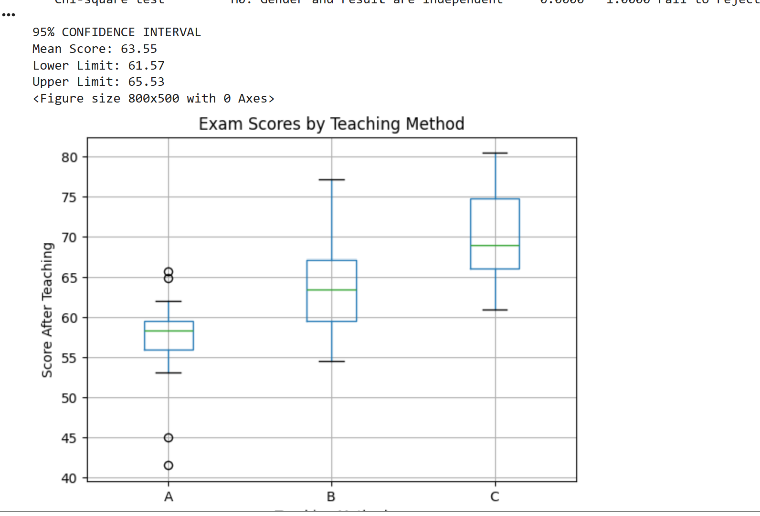

Experiment 9: Acquiring Rules from Data with Decision Trees
Aim: To acquire knowledge automatically from data as IF-THEN rules, evaluate it rigorously, and compare it with hand-written expert rules.

Code:
import pandas as pd
import numpy as np
import matplotlib.pyplot as plt

from sklearn.datasets import load_breast_cancer
from sklearn.model_selection import train_test_split, cross_val_score
from sklearn.tree import DecisionTreeClassifier, export_text
from sklearn.metrics import (
accuracy_score, confusion_matrix,
precision_score, recall_score, f1_score
)

# ------------------------------------------------
# 1. LOAD BREAST CANCER DATASET
# ------------------------------------------------

data = load_breast_cancer()

X = pd.DataFrame(data.data, columns=data.feature_names)
y = pd.Series(data.target)

print("Dataset Shape:", X.shape)
print("\nFeature Names:")
print(X.columns.tolist())

print("\nTarget Classes:")
print(data.target_names)

# ------------------------------------------------
# 2. SPLIT DATA INTO TRAINING AND TESTING
# ------------------------------------------------

X_train, X_test, y_train, y_test = train_test_split(
X, y,
test_size=0.30,
random_state=42,
stratify=y
)

print("\nTraining Size:", X_train.shape)
print("Testing Size:", X_test.shape)

# ------------------------------------------------
# 3. BASELINE MODEL - MAJORITY CLASS
# ------------------------------------------------

majority_class = y_train.mode()[0]

baseline_predictions = np.full(
len(y_test), majority_class
)

baseline_accuracy = accuracy_score(
y_test, baseline_predictions
)

print("\nBaseline Accuracy:", round(baseline_accuracy, 4))

# ------------------------------------------------
# 4. HAND-WRITTEN EXPERT RULES
# ------------------------------------------------

# Target 0 = Malignant
# Target 1 = Benign

def expert_rules(X):

predictions = []

for _, row in X.iterrows():

# Rule 1
if row["mean radius"] > 17:
prediction = 0

# Rule 2
elif row["worst concave points"] > 0.15:
prediction = 0

# Rule 3
elif row["worst perimeter"] > 115:
prediction = 0

# Rule 4
elif row["mean concavity"] > 0.12:
prediction = 0

else:
prediction = 1

predictions.append(prediction)

return np.array(predictions)

expert_predictions = expert_rules(X_test)

expert_accuracy = accuracy_score(
y_test, expert_predictions
)

print("\nExpert Rules Accuracy:",
round(expert_accuracy, 4))

# ------------------------------------------------
# 5. TRAIN DECISION TREES WITH DIFFERENT DEPTHS
# ------------------------------------------------

depths = [2, 3, 4, 6]

tree_results = []
models = {}

for depth in depths:

model = DecisionTreeClassifier(
max_depth=depth,
random_state=42
)

model.fit(X_train, y_train)

models[depth] = model

train_predictions = model.predict(X_train)
test_predictions = model.predict(X_test)

train_accuracy = accuracy_score(
y_train, train_predictions
)

test_accuracy = accuracy_score(
y_test, test_predictions
)

cv_scores = cross_val_score(
model,
X_train,
y_train,
cv=5,
scoring="accuracy"
)

cv_accuracy = cv_scores.mean()

tree_results.append([
depth,
train_accuracy,
test_accuracy,
cv_accuracy
])

print("\nDecision Tree Depth:", depth)
print("Training Accuracy:", round(train_accuracy, 4))
print("Testing Accuracy:", round(test_accuracy, 4))
print("5-Fold CV Accuracy:", round(cv_accuracy, 4))

# ------------------------------------------------
# 6. COMPARISON TABLE
# ------------------------------------------------

comparison = [
["Baseline", "-", baseline_accuracy, "-"],
["Expert Rules", "-", expert_accuracy, "-"]
]

for depth, train_acc, test_acc, cv_acc in tree_results:

comparison.append([
"Decision Tree",
depth,
test_acc,
cv_acc
])

comparison_df = pd.DataFrame(
comparison,
columns=[
"Model",
"Depth",
"Test Accuracy",
"Cross Validation Accuracy"
]
)

print("\nMODEL COMPARISON")
print(comparison_df.to_string(index=False))

# ------------------------------------------------
# 7. PLOT ACCURACY AGAINST TREE DEPTH
# ------------------------------------------------

train_values = [r[1] for r in tree_results]
test_values = [r[2] for r in tree_results]
cv_values = [r[3] for r in tree_results]

plt.figure(figsize=(8, 5))

plt.plot(depths, train_values, marker="o",
label="Training Accuracy")

plt.plot(depths, test_values, marker="o",
label="Testing Accuracy")

plt.plot(depths, cv_values, marker="o",
label="Cross Validation Accuracy")

plt.xlabel("Decision Tree Depth")
plt.ylabel("Accuracy")
plt.title("Accuracy vs Decision Tree Depth")

plt.legend()
plt.grid(True)
plt.show()

# ------------------------------------------------
# 8. SELECT BEST TREE USING CROSS VALIDATION
# ------------------------------------------------

best_depth = max(
tree_results,
key=lambda r: (r[3], -r[0])
)[0]

best_model = models[best_depth]

print("\nSelected Tree Depth:", best_depth)

# ------------------------------------------------
# 9. DISPLAY DECISION TREE RULES
# ------------------------------------------------

tree_rules = export_text(
best_model,
feature_names=list(X.columns)
)

print("\nDECISION TREE IF-THEN RULES")
print(tree_rules)

# Count leaf rules and conditions
rule_count = sum(
1 for line in tree_rules.splitlines()
if "class:" in line
)

condition_count = sum(
1 for line in tree_rules.splitlines()
if "<=" in line or ">" in line
)

print("Number of Rules:", rule_count)
print("Number of Conditions:", condition_count)

# ------------------------------------------------
# 10. CONFUSION MATRIX AND PERFORMANCE METRICS
# ------------------------------------------------

tree_predictions = best_model.predict(X_test)

def evaluate_model(name, actual, predicted):

print("\n", name)

print("Confusion Matrix:")
print(confusion_matrix(actual, predicted))

print("Precision:",
round(precision_score(actual, predicted,
zero_division=0), 4))

print("Recall:",
round(recall_score(actual, predicted,
zero_division=0), 4))

print("F1 Score:",
round(f1_score(actual, predicted,
zero_division=0), 4))

evaluate_model(
"Decision Tree Evaluation",
y_test,
tree_predictions
)

evaluate_model(
"Expert Rules Evaluation",
y_test,
expert_predictions
)

# ------------------------------------------------
# 11. FINAL CRITIQUE
# ------------------------------------------------

print("""
CRITIQUE:

The decision tree automatically learns IF-THEN rules from
the training data and provides measurable performance.
The expert rules are manually written and are easier to
understand, but their accuracy depends on the selected
conditions and thresholds.

A shallow decision tree is generally easier to interpret,
while a deeper tree may learn more complex patterns.
However, a large difference between training and testing
accuracy can indicate overfitting.

The comparison of accuracy, precision, recall and F1-score
helps identify the strengths and weaknesses of both
approaches. Recall is especially important when evaluating
missed positive cases. The final model should be selected
using cross-validation and test performance rather than
training accuracy alone.

These rules are for educational demonstration only and
must not be used for medical diagnosis.
""")

Output:
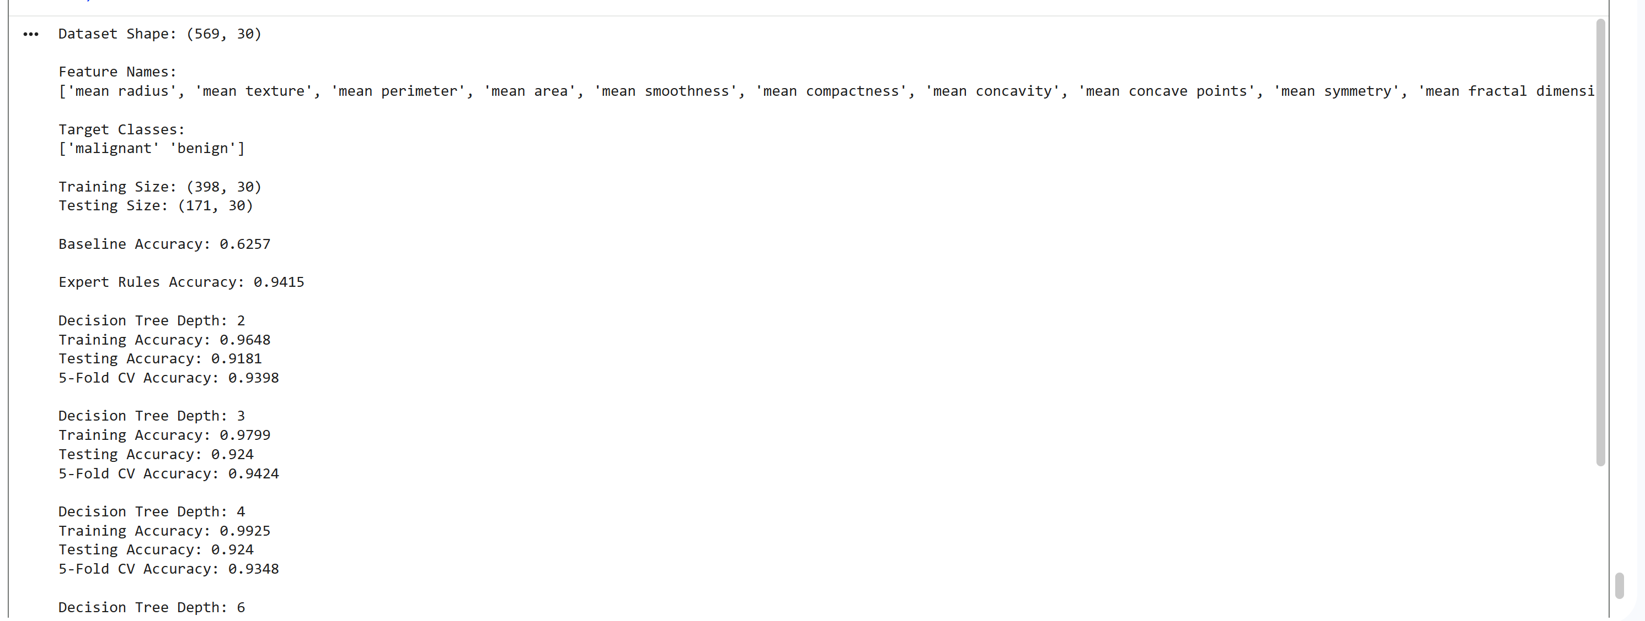
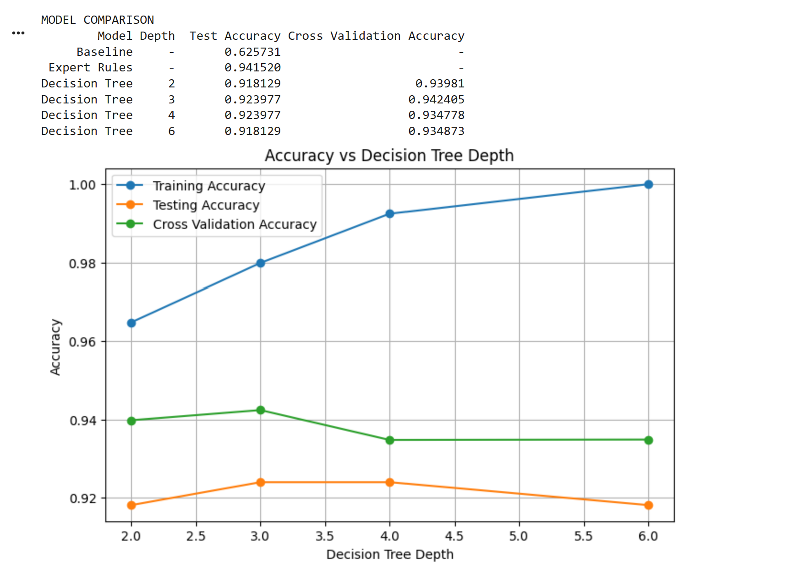
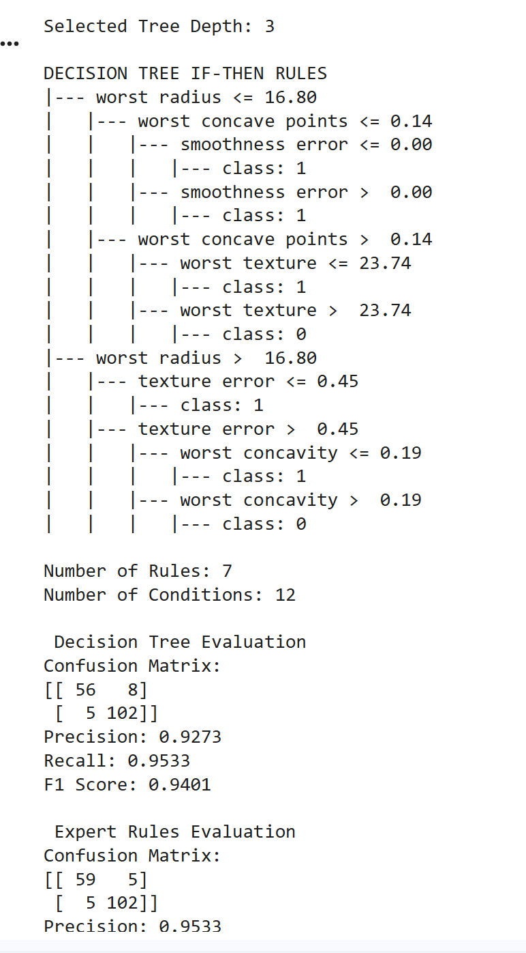

Experiment 10: Hybrid Decision-Support System (Knowledge Graph, Rules and Machine Learning)
Aim: To design, build and evaluate a decision-support system that combines a knowledge graph, an expert rule base and a machine learning model, and explains its recommendations.

Code:

import pandas as pd
import numpy as np
import matplotlib.pyplot as plt

from rdflib import Graph, Namespace, Literal, RDF, RDFS

from sklearn.ensemble import RandomForestClassifier
from sklearn.model_selection import train_test_split, cross_val_score
from sklearn.metrics import (
accuracy_score,
precision_score,
recall_score,
f1_score,
confusion_matrix
)

# ------------------------------------------------
# 1. GENERATE SYNTHETIC DATASET (150 STUDENTS)
# ------------------------------------------------

np.random.seed(42)

n = 150

data = pd.DataFrame({
"AI_interest": np.random.randint(1, 11, n),
"Web_interest": np.random.randint(1, 11, n),
"Data_interest": np.random.randint(1, 11, n),
"Math_score": np.random.randint(40, 101, n),
"Coding_score": np.random.randint(1, 11, n),
"Communication": np.random.randint(1, 11, n),
"Workload": np.random.randint(1, 11, n)
})

# Generate course recommendation labels

ai_score = (
data["AI_interest"] * 0.35
+ data["Coding_score"] * 0.25
+ data["Math_score"] / 10 * 0.25
+ np.random.normal(0, 1, n)
)

web_score = (
data["Web_interest"] * 0.40
+ data["Communication"] * 0.20
+ data["Coding_score"] * 0.20
+ np.random.normal(0, 1, n)
)

ds_score = (
data["Data_interest"] * 0.35
+ data["Math_score"] / 10 * 0.30
+ data["Coding_score"] * 0.15
+ np.random.normal(0, 1, n)
)

scores = np.column_stack([ai_score, web_score, ds_score])

classes = np.array(["AI", "Web", "Data Science"])

data["Recommendation"] = classes[np.argmax(scores, axis=1)]

data.to_csv("student_courses.csv", index=False)

print("DATASET")
print(data.head())
print("\nDataset Shape:", data.shape)

# ------------------------------------------------
# 2. CREATE KNOWLEDGE GRAPH
# ------------------------------------------------

kg = Graph()

EX = Namespace("http://example.org/course/")
kg.bind("ex", EX)

# Define classes using RDFS.Class

kg.add((EX.Student, RDF.type, RDFS.Class))
kg.add((EX.Course, RDF.type, RDFS.Class))

# Define course entities

courses = ["AI", "Web", "DataScience"]

for course in courses:
kg.add((EX[course], RDF.type, EX.Course))

# Add student information

for i, row in data.iterrows():

student = EX["Student" + str(i)]

kg.add((student, RDF.type, EX.Student))

interests = {
"AI": row["AI_interest"],
"Web": row["Web_interest"],
"DataScience": row["Data_interest"]
}

preferred = max(interests, key=interests.get)

kg.add((
student,
EX.hasInterest,
EX[preferred]
))

if row["Coding_score"] >= 6:
kg.add((student, EX.hasSkill, EX.Coding))

if row["Math_score"] >= 60:
kg.add((student, EX.hasSkill, EX.Mathematics))

if row["Communication"] >= 6:
kg.add((student, EX.hasSkill, EX.Communication))

print("\nKNOWLEDGE GRAPH CREATED")
print("Total Triples:", len(kg))

# ------------------------------------------------
# 3. DEFINE EXPERT RULES WITH CERTAINTY FACTORS
# ------------------------------------------------

def apply_rules(row, graph, student_id):

rule_scores = {
"AI": 0.10,
"Web": 0.10,
"Data Science": 0.10
}

fired_rules = []

student = EX["Student" + str(student_id)]

# Get interest from Knowledge Graph

interest = list(
graph.objects(student, EX.hasInterest)
)

preferred = (
str(interest[0]).split("/")[-1]
if interest else None
)

# Map graph entity to recommendation label

if preferred == "DataScience":
preferred = "Data Science"

# Rule 1

if row["AI_interest"] >= 7 and row["Coding_score"] >= 6:
rule_scores["AI"] += 0.80
fired_rules.append(
"R1: High AI interest and coding (+0.80)"
)

# Rule 2

if row["Math_score"] >= 70 and row["Coding_score"] >= 7:
rule_scores["AI"] += 0.60
fired_rules.append(
"R2: Good mathematics and coding (+0.60)"
)

# Rule 3 - Negative evidence

if row["AI_interest"] <= 3:
rule_scores["AI"] -= 0.60
fired_rules.append(
"R3: Low AI interest (-0.60)"
)

# Rule 4

if row["Data_interest"] >= 7:
rule_scores["Data Science"] += 0.80
fired_rules.append(
"R4: High data science interest (+0.80)"
)

# Rule 5

if row["Math_score"] >= 65 and row["Coding_score"] >= 5:
rule_scores["Data Science"] += 0.50
fired_rules.append(
"R5: Mathematics and coding skills (+0.50)"
)

# Rule 6 - Negative evidence

if row["Data_interest"] <= 3:
rule_scores["Data Science"] -= 0.50
fired_rules.append(
"R6: Low data science interest (-0.50)"
)

# Rule 7

if row["Web_interest"] >= 7:
rule_scores["Web"] += 0.80
fired_rules.append(
"R7: High web development interest (+0.80)"
)

# Rule 8

if row["Communication"] >= 7 and row["Coding_score"] >= 5:
rule_scores["Web"] += 0.50
fired_rules.append(
"R8: Communication and coding skills (+0.50)"
)

# Rule 9 - Negative evidence

if row["Web_interest"] <= 3:
rule_scores["Web"] -= 0.50
fired_rules.append(
"R9: Low web development interest (-0.50)"
)

# Rule 10 - Knowledge Graph evidence

if preferred in rule_scores:
rule_scores[preferred] += 0.25

fired_rules.append(
"R10: Knowledge Graph interest supports "
+ preferred + " (+0.25)"
)

# Remove negative values

for course in rule_scores:
rule_scores[course] = max(0, rule_scores[course])

# Normalize rule scores

total = sum(rule_scores.values())

if total == 0:
probabilities = {
course: 1 / 3 for course in rule_scores
}
else:
probabilities = {
course: value / total
for course, value in rule_scores.items()
}

return probabilities, fired_rules, preferred

# ------------------------------------------------
# 4. SPLIT DATA INTO TRAINING AND TESTING
# ------------------------------------------------

features = [
"AI_interest",
"Web_interest",
"Data_interest",
"Math_score",
"Coding_score",
"Communication",
"Workload"
]

X = data[features]
y = data["Recommendation"]

X_train, X_test, y_train, y_test = train_test_split(
X,
y,
test_size=0.20,
random_state=42,
stratify=y
)

print("\nTRAINING AND TESTING DATA")
print("Training Records:", len(X_train))
print("Testing Records:", len(X_test))

# ------------------------------------------------
# 5. MACHINE LEARNING MODEL
# ------------------------------------------------

model = RandomForestClassifier(
n_estimators=100,
random_state=42
)

model.fit(X_train, y_train)

# 5-fold cross-validation

cv_scores = cross_val_score(
model,
X_train,
y_train,
cv=5,
scoring="accuracy"
)

print("\nCROSS VALIDATION SCORES")
print(cv_scores)

print(
"Average CV Accuracy:",
round(cv_scores.mean(), 4)
)

# ------------------------------------------------
# 6. PREDICTIONS FROM THREE SYSTEMS
# ------------------------------------------------

# Model alone

model_predictions = model.predict(X_test)

# Rules alone

rule_predictions = []
rule_probabilities = []

for index, row in X_test.iterrows():

probabilities, fired, preferred = apply_rules(
row, kg, index
)

rule_probabilities.append(probabilities)

rule_predictions.append(
max(probabilities, key=probabilities.get)
)

rule_predictions = np.array(rule_predictions)

# Hybrid system

hybrid_predictions = []

for i, probabilities in enumerate(rule_probabilities):

ml_probabilities = model.predict_proba(
X_test.iloc[[i]]
)[0]

ml_scores = dict(
zip(model.classes_, ml_probabilities)
)

# 55% ML model + 45% expert rules

combined_scores = {}

for course in classes:

rule_score = probabilities[course]
ml_score = ml_scores[course]

combined_scores[course] = (
0.55 * ml_score
+ 0.45 * rule_score
)

hybrid_predictions.append(
max(combined_scores, key=combined_scores.get)
)

hybrid_predictions = np.array(hybrid_predictions)

# ------------------------------------------------
# 7. BASELINE SYSTEM
# ------------------------------------------------

majority_class = y_train.mode()[0]

baseline_predictions = np.full(
len(y_test),
majority_class
)

# ------------------------------------------------
# 8. EVALUATE FOUR SYSTEMS
# ------------------------------------------------

systems = {
"Baseline": baseline_predictions,
"Rules Only": rule_predictions,
"ML Model": model_predictions,
"Hybrid System": hybrid_predictions
}

results = []

for name, predictions in systems.items():

accuracy = accuracy_score(y_test, predictions)

precision = precision_score(
y_test,
predictions,
average="macro",
zero_division=0
)

recall = recall_score(
y_test,
predictions,
average="macro",
zero_division=0
)

f1 = f1_score(
y_test,
predictions,
average="macro",
zero_division=0
)

results.append([
name,
accuracy,
precision,
recall,
f1
])

print("\n", name)

print("Confusion Matrix:")

print(
confusion_matrix(
y_test,
predictions,
labels=classes
)
)

results_df = pd.DataFrame(
results,
columns=[
"System",
"Accuracy",
"Precision",
"Recall",
"F1 Score"
]
)

print("\nFINAL SYSTEM COMPARISON")

print(results_df.round(4).to_string(index=False))

# ------------------------------------------------
# 9. DISPLAY FIVE SAMPLE EXPLANATIONS
# ------------------------------------------------

print("\nFIVE SAMPLE RECOMMENDATIONS AND EXPLANATIONS")

for i in range(min(5, len(X_test))):

index = X_test.index[i]
row = X_test.iloc[i]

probabilities, fired_rules, preferred = apply_rules(
row, kg, index
)

ml_probabilities = model.predict_proba(
X_test.iloc[[i]]
)[0]

ml_scores = dict(
zip(model.classes_, ml_probabilities)
)

hybrid_scores = {}

for course in classes:

hybrid_scores[course] = (
0.55 * ml_scores[course]
+ 0.45 * probabilities[course]
)

recommendation = max(
hybrid_scores,
key=hybrid_scores.get
)

print("\nStudent:", index)

print("Knowledge Graph Interest:", preferred)

print("\nFACTS USED")

print("AI Interest:", row["AI_interest"])
print("Web Interest:", row["Web_interest"])
print("Data Interest:", row["Data_interest"])
print("Math Score:", row["Math_score"])
print("Coding Score:", row["Coding_score"])

print("\nRULES FIRED")

for rule in fired_rules:
print("-", rule)

print(
"\nML Model Confidence:",
round(ml_scores[recommendation] * 100, 2),
"%"
)

print(
"Hybrid Recommendation Score:",
round(hybrid_scores[recommendation] * 100, 2),
"%"
)

print("FINAL RECOMMENDATION:", recommendation)

# ------------------------------------------------
# 10. ANALYSE ONE FAILURE CASE
# ------------------------------------------------

wrong = np.where(
hybrid_predictions != y_test.values
)[0]

print("\nFAILURE CASE ANALYSIS")

if len(wrong) > 0:

i = wrong[0]

print("Student:", X_test.index[i])
print("Actual Course:", y_test.iloc[i])
print("Predicted Course:", hybrid_predictions[i])

print(
"Reason: The weighted rule and ML scores selected "
"a different course."
)

print(
"Possible cause: Synthetic data variation "
"or incomplete expert rules."
)

else:

print("No failure cases found in this test set.")

# ------------------------------------------------
# 11. VISUALIZE SYSTEM ACCURACY
# ------------------------------------------------

plt.figure(figsize=(8, 5))

plt.bar(
results_df["System"],
results_df["Accuracy"]
)

plt.xlabel("Decision Support Systems")
plt.ylabel("Accuracy")

plt.title(
"Comparison of Four Decision Support Systems"
)

plt.ylim(0, 1)
plt.grid(axis="y")

plt.xticks(rotation=15)

plt.tight_layout()
plt.show()

# ------------------------------------------------
# 12. DISPLAY KNOWLEDGE GRAPH TRIPLES
# ------------------------------------------------

print("\nSAMPLE KNOWLEDGE GRAPH TRIPLES")

for triple in list(kg)[:10]:
print(triple)

print(
"\nTOTAL KNOWLEDGE GRAPH TRIPLES:",
len(kg)
)

# Save Knowledge Graph

kg.serialize(
destination="course_knowledge_graph.ttl",
format="turtle"
)

print("\nKnowledge Graph saved successfully.")
print("Dataset saved as student_courses.csv")

Output:
